1.Write a Terraform script to provision an EC2 instance.
Open VS Code
Open VS Code → File → Open Folder
Create/select a folder, for example:
D:\Terraform\Provisioning EC2 Instance

Configure AWS
In the VS Code terminal:
aws configure
Enter:
AWS Access Key ID: YOUR_ACCESS_KEY
AWS Secret Access Key: YOUR_SECRET_KEY
Default region name: ap-south-2
Default output format: json
Don't put the secret key in main.tf.

1. Create main.tf
terraform {
required_providers {
aws = {
source = "hashicorp/aws"
}
}
}

provider "aws" {
region = "us-east-1"
}

resource "aws_instance" "web_server" {
ami = "ami-0c02fb55956c7d316"
instance_type = "t3.micro"

tags = {
Name = "Terraform-EC2"
}
}

2. Run Terraform commands
terraform init
Initializes Terraform and downloads the AWS provider.
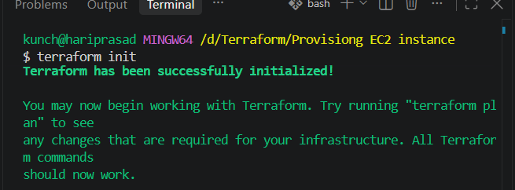
When initialize it will create
.terraform folder
.terraform.lock.hcl file creates
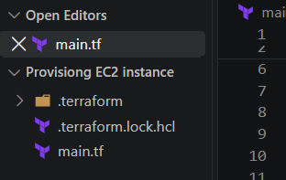
terraform validate
Checks whether the Terraform configuration is valid.
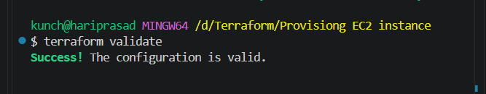

terraform plan
Shows what Terraform is going to create.
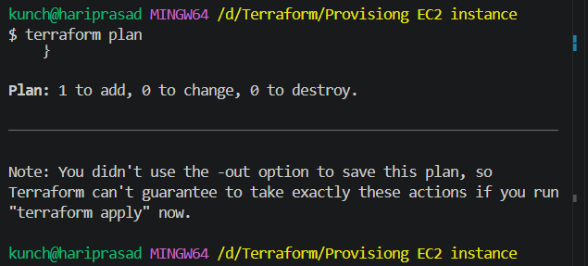
terraform apply
Creates the EC2 instance.
Type:
yes
when Terraform asks for confirmation.
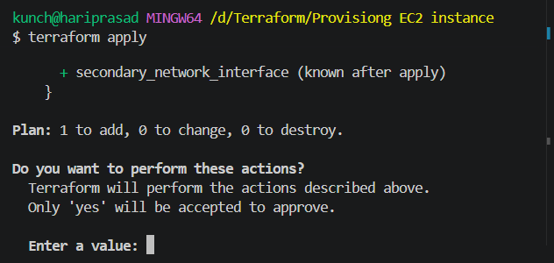
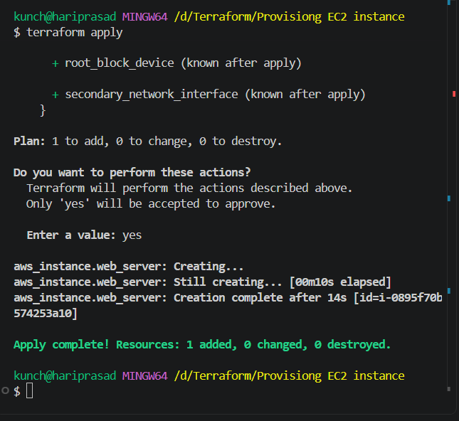

3. Verify the instance
After terraform apply, you should see something similar to:
Apply complete! Resources: 1 added, 0 changed, 0 destroyed.
Go to AWS Console → EC2 → Instances and look for:
Terraform-EC2
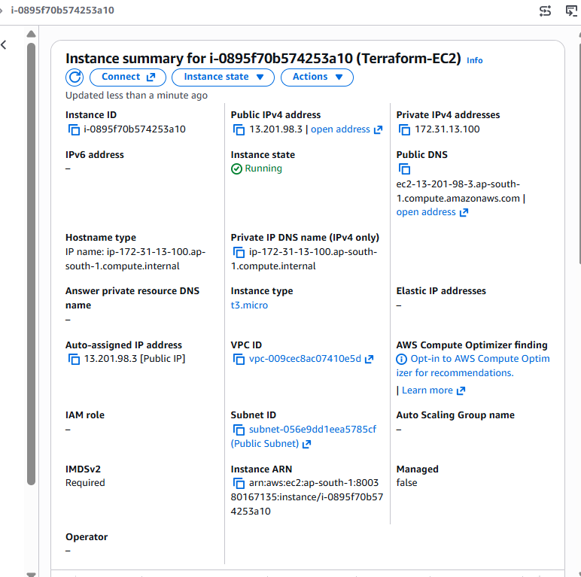

2. Write a Terraform script to provision an S3 bucket.
1. Create main.tf
Terraform S3 Bucket Provisioning Script
terraform {
required_providers {
aws = {
source = "hashicorp/aws"
}
}
}

provider "aws" {
region = "us-east-1"
}

resource "aws_s3_bucket" "my_bucket" {
bucket = "my-terraform-demo-bucket-123456"

tags = {
Name = "Terraform-Demo-Bucket"
Environment = "Dev"
}
}
2. Run Terraform commands
Initialize Terraform:
terraform init
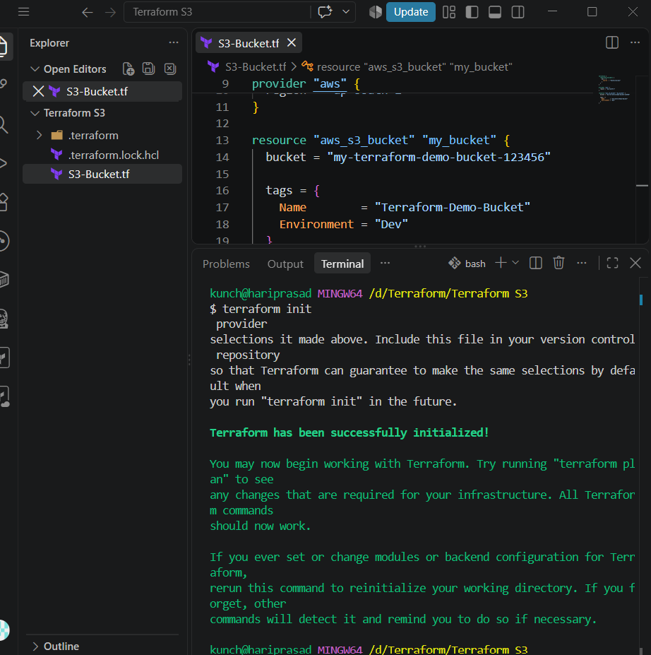
Validate the configuration:
terraform validate

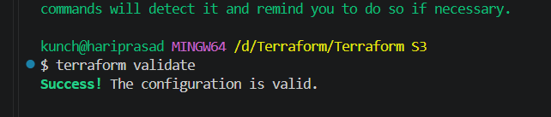
Preview what Terraform will create:
terraform plan
Create the S3 bucket:
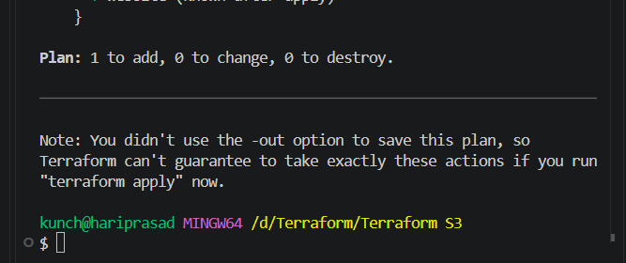
terraform apply
When prompted:
Do you want to perform these actions?
Enter:
yes
You should see:
Apply complete! Resources: 1 added, 0 changed, 0 destroyed.
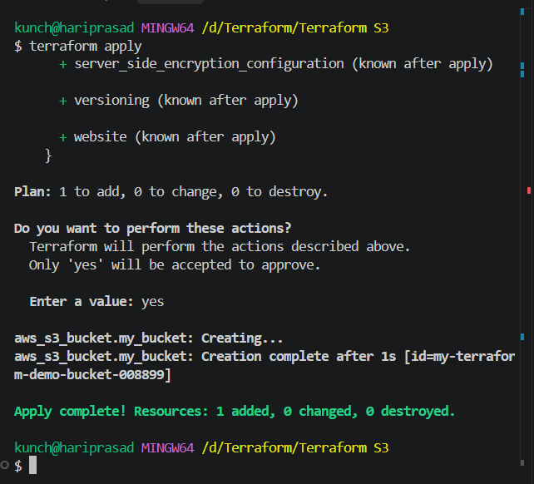
3. Verify in AWS
Go to:
AWS Console → S3 → Buckets
You should see:
my-terraform-demo-bucket-008899
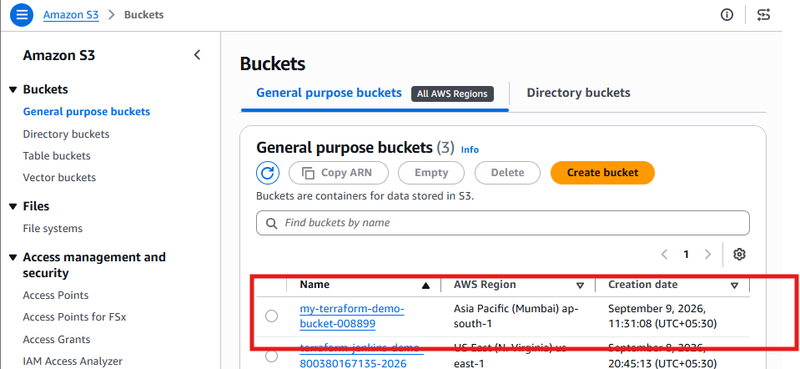

3.Write a Terraform script to provision 3 EC2 instances in 3 different regions.
For example:
- EC2-1 → us-east-1 (N. Virginia)
- EC2-2 → ap-south-1 (Mumbai)
- EC2-3 → ap-southeast-1 (Singapore)
main.tf
Terraform – 3 EC2 Instances in 3 Different Regions
terraform {
required_providers {
aws = {
source = "hashicorp/aws"
}
}
}

# Provider 1 - US East (N. Virginia)
provider "aws" {
alias = "virginia"
region = "us-east-1"
}

# Provider 2 - Asia Pacific (Mumbai)
provider "aws" {
alias = "mumbai"
region = "ap-south-1"
}

# Provider 3 - Asia Pacific (Singapore)
provider "aws" {
alias = "singapore"
region = "ap-southeast-1"
}

# EC2 Instance 1 - Virginia
resource "aws_instance" "virginia_server" {
provider = aws.virginia
ami = "ami-081b0a6eac00b4f53"
instance_type = "t3.micro"

tags = {
Name = "Terraform-EC2-Virginia"
}
}

# EC2 Instance 2 - Mumbai
resource "aws_instance" "mumbai_server" {
provider = aws.mumbai
ami = "ami-090d68841c2a28756"
instance_type = "t3.micro"

tags = {
Name = "Terraform-EC2-Mumbai"
}
}

# EC2 Instance 3 - Singapore
resource "aws_instance" "singapore_server" {
provider = aws.singapore
ami = "ami-02159ad7e38d562f2"
instance_type = "t3.micro"

tags = {
Name = "Terraform-EC2-Singapore"
}
}
Step 2: Initialize Terraform
terraform init
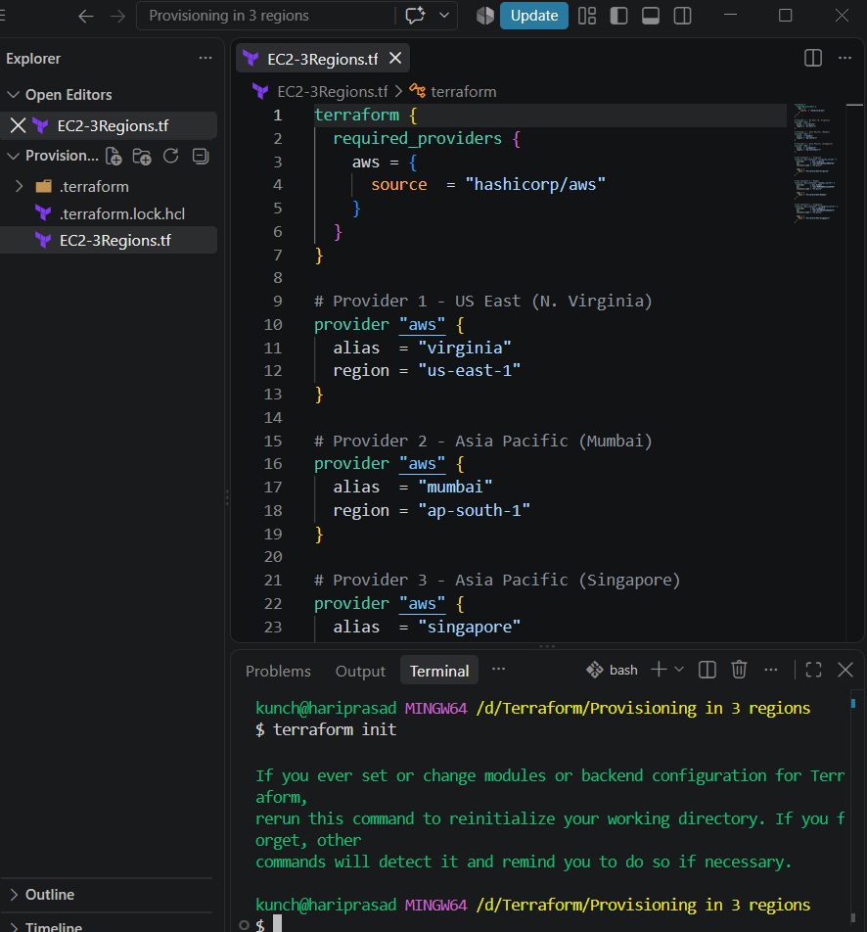

Step 3: Validate
terraform validate
Expected:
Success! The configuration is valid.
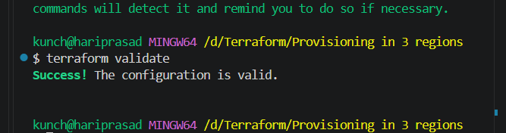
Step 4: Check the plan
terraform plan
Terraform should show:
Plan: 3 to add, 0 to change, 0 to destroy.
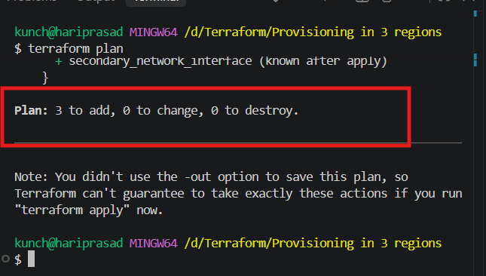
Step 5: Create the instances
terraform apply
Enter:
Yes
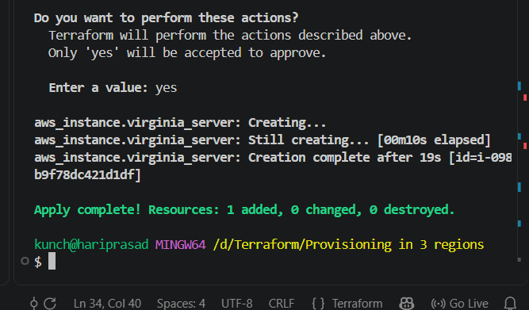
Terraform will create:
EC2-1 → us-east-1 → Virginia
EC2-2 → ap-south-1 → Mumbai
EC2-3 → ap-southeast-1 → Singapore
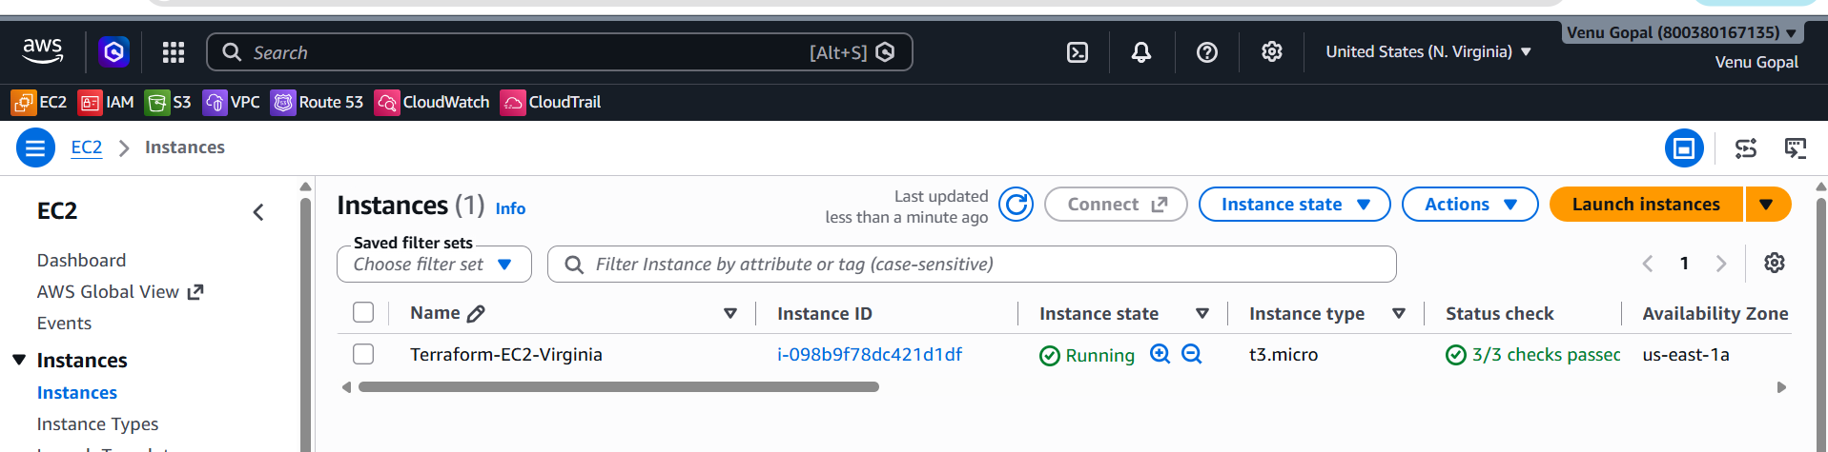
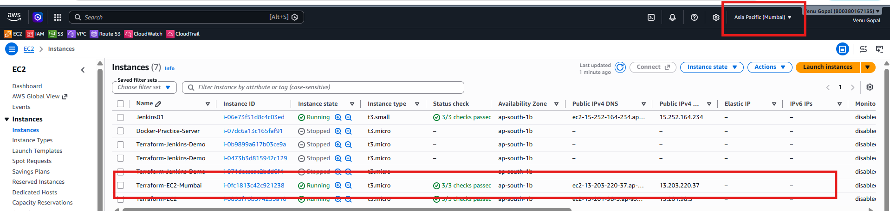
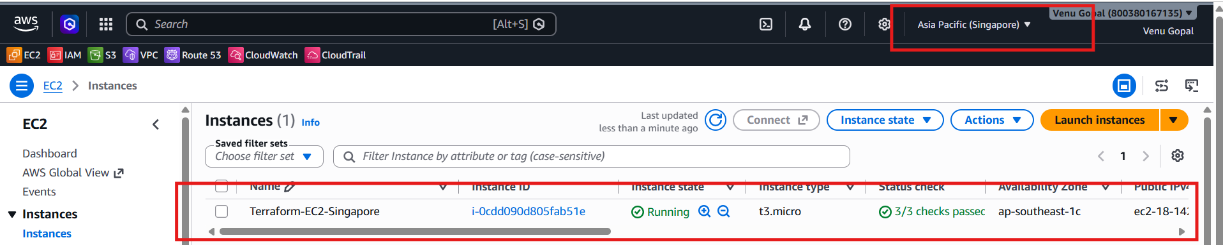
Step 6: Destroy everything
After your practice:
terraform destroy
Enter:
yes
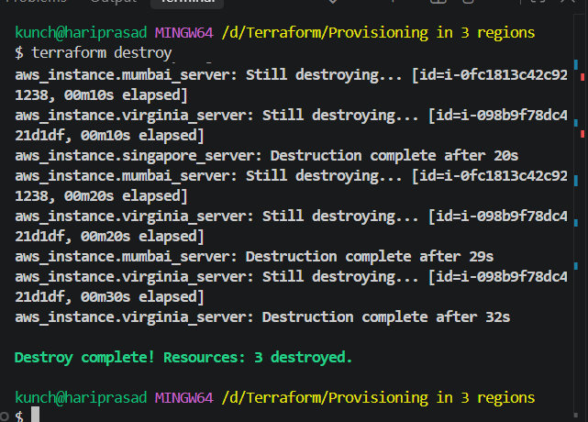
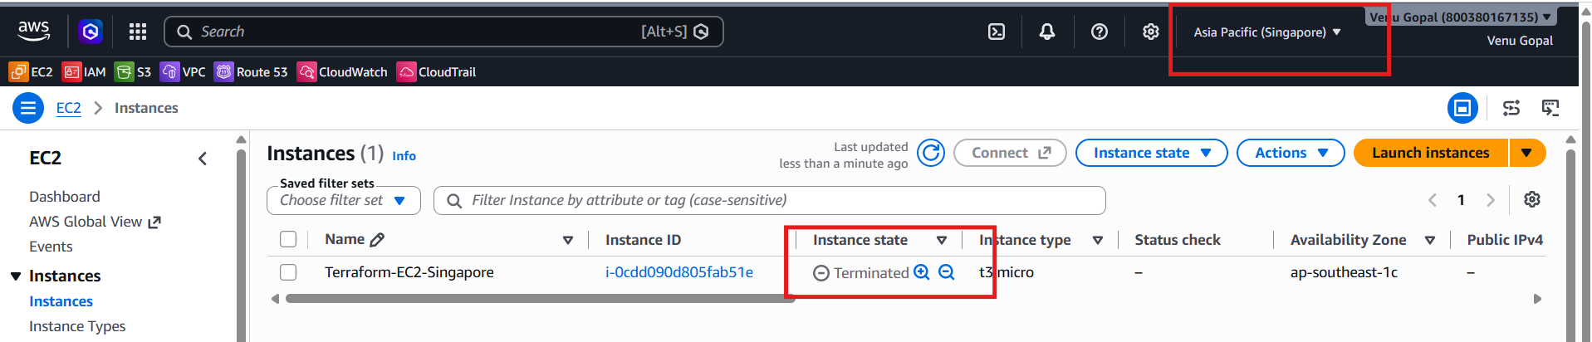

4.Write a Terraform script to provision multiple EC2 instances using count and for_each.
1. Using count
count is useful when you want to create multiple similar resources.
main.tf
terraform {
required_providers {
aws = {
source = "hashicorp/aws"
}
}
}

provider "aws" {
region = "us-east-1"
}

# --------------------------------------------------
# EC2 INSTANCES USING COUNT
# --------------------------------------------------

resource "aws_instance" "count_example" {
count = 3

ami = "ami-0c02fb55956c7d316"
instance_type = "t3.micro"

tags = {
Name = "Count-Server-${count.index + 1}"
}
}

# --------------------------------------------------
# EC2 INSTANCES USING FOR_EACH
# --------------------------------------------------

variable "servers" {
default = {
dev = "t3.micro"
test = "t3.micro"
prod = "t3.small"
}
}

resource "aws_instance" "foreach_example" {
for_each = var.servers

ami = "ami-0c02fb55956c7d316"
instance_type = each.value

tags = {
Name = "ForEach-${each.key}"
Environment = each.key
}
}
2. count explanation
This block:
resource "aws_instance" "count_example" {
count = 3
}
creates 3 EC2 instances.
Terraform internally creates:
aws_instance.count_example[0]
aws_instance.count_example[1]
aws_instance.count_example[2]
And this:
Name = "Count-Server-${count.index + 1}"
produces:
Count-Server-1
Count-Server-2
Count-Server-3

3. for_each explanation
We define a map:
variable "servers" {
default = {
dev = "t3.micro"
test = "t3.micro"
prod = "t3.small"
}
}
Then:
for_each = var.servers
creates one instance for each map entry.
Terraform creates:
aws_instance.foreach_example["dev"]
aws_instance.foreach_example["test"]
aws_instance.foreach_example["prod"]
The values are accessed using:
each.key
and:
each.value
So:
Key | Value | Instance Type
dev | t3.micro | t3.micro
test | t3.micro | t3.micro
prod | t3.small | t3.small

4. Run the Terraform commands
Initialize:
terraform init
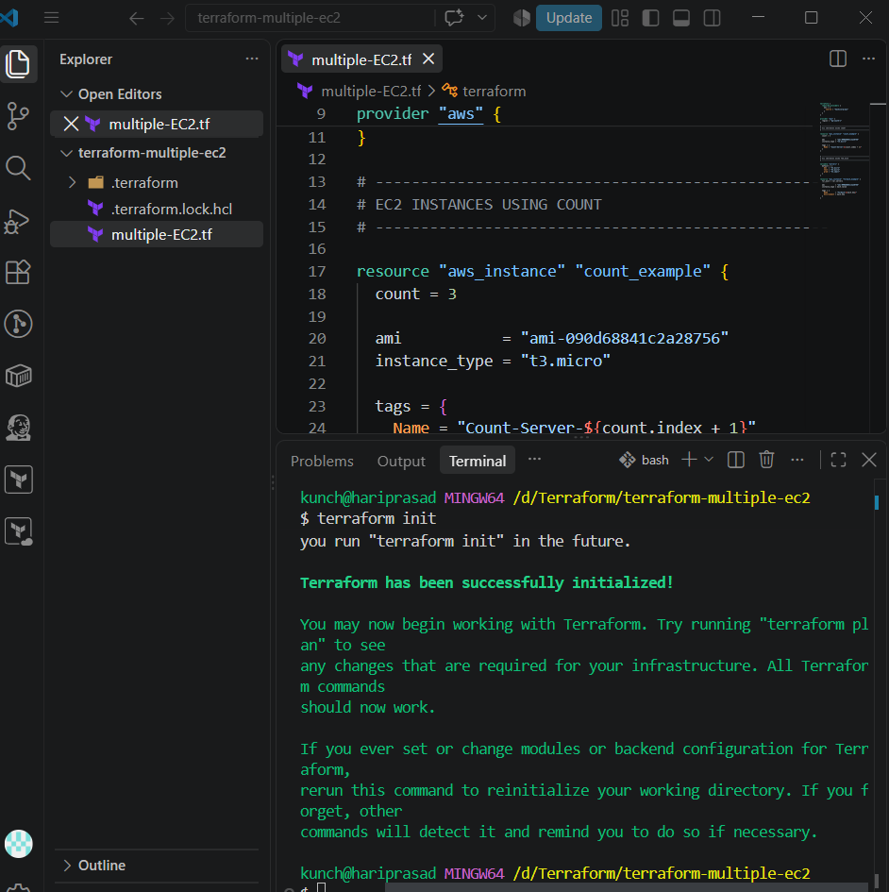
Validate:
terraform validate
Preview:
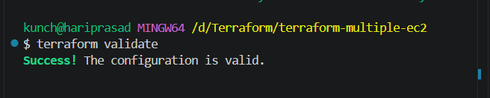
terraform plan
Because we're creating 3 instances with count and 3 with for_each, Terraform should plan for:
Plan: 6 to add, 0 to change, 0 to destroy.
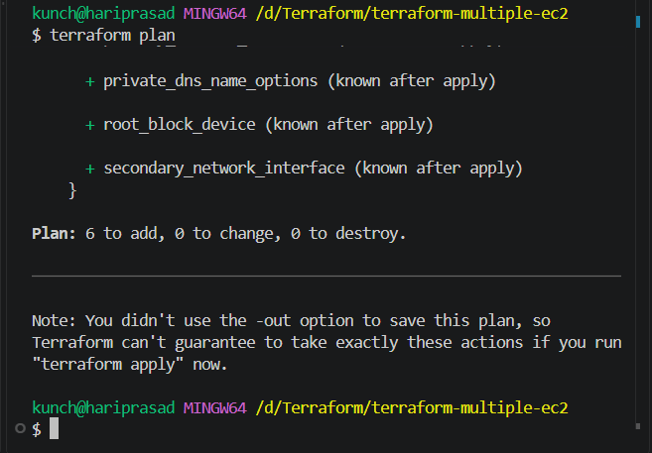
Create them:
terraform apply
Enter:
Yes
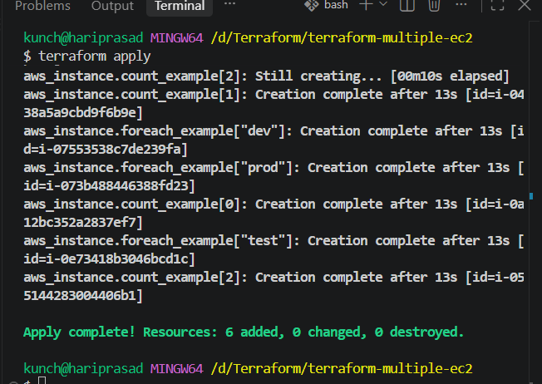

5. Verify the resources
Run:
terraform state list
You should see something similar to:
aws_instance.count_example[0]
aws_instance.count_example[1]
aws_instance.count_example[2]

aws_instance.foreach_example["dev"]
aws_instance.foreach_example["prod"]
aws_instance.foreach_example["test"]
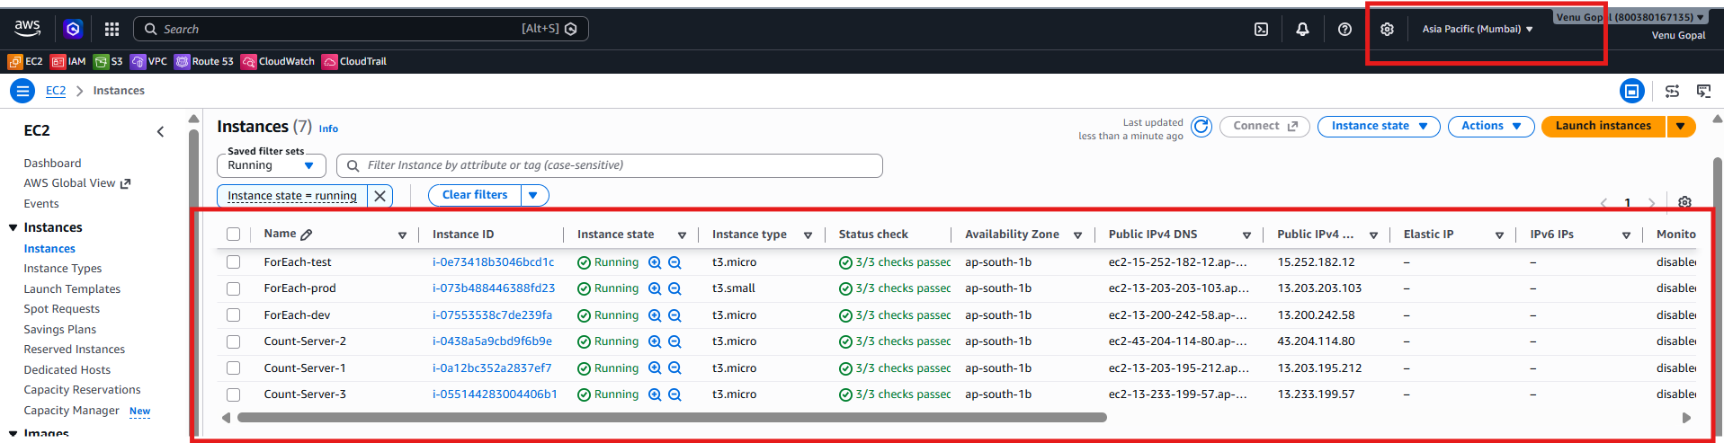

6. Destroy the resources
terraform destroy
Enter:
yes
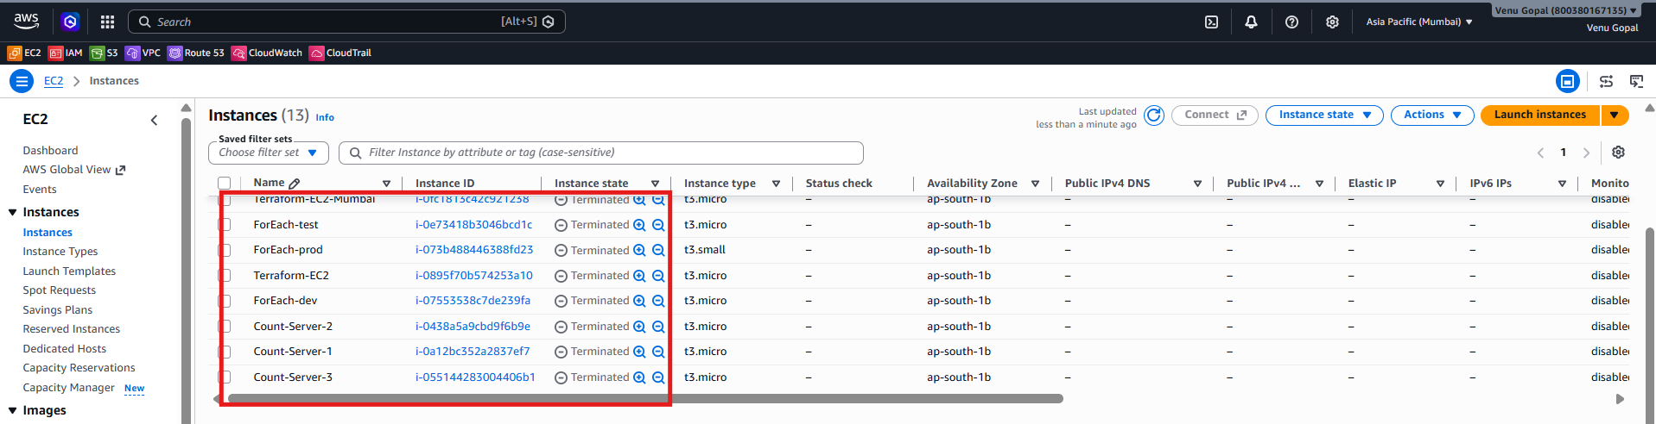
5.Write a Terraform script to provision an EC2 instance using a module.
6.Write a Terraform script to provision an RDS database instance.
create a separate Terraform project so you can practice it independently.
📁 Folder name
terraform-rds
Structure:
terraform-rds/
└── main.tf
main.tf
terraform {
required_providers {
aws = {
source = "hashicorp/aws"
version = "~> 6.0"
}
}
}

provider "aws" {
region = "us-east-1"
}

resource "aws_db_instance" "my_database" {
identifier = "terraform-rds-demo"

engine = "mysql"
engine_version = "8.0"

instance_class = "db.t3.micro"
allocated_storage = 20
max_allocated_storage = 100

db_name = "myappdb"
username = "admin"
password = "Terraform008899"

publicly_accessible = false
skip_final_snapshot = true
deletion_protection = false

backup_retention_period = 0

tags = {
Name = "Terraform-RDS"
Environment = "Dev"
}
}
Step 1 — Initialize Terraform
Open the VS Code terminal inside terraform-rds:
terraform init
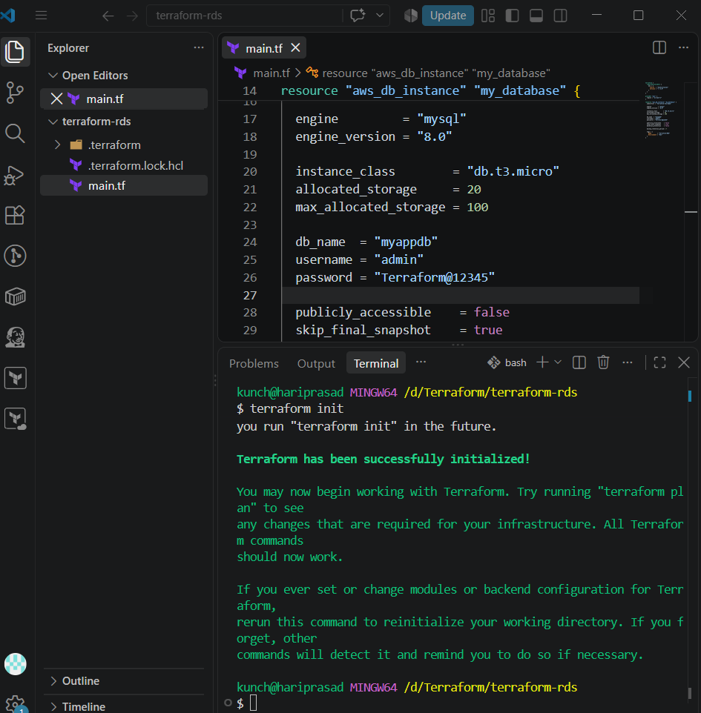
Step 2 — Validate
terraform validate
Expected:
Success! The configuration is valid.
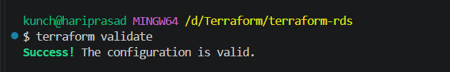
Step 3 — Create execution plan
terraform plan
You should see approximately:
Plan: 1 to add, 0 to change, 0 to destroy.
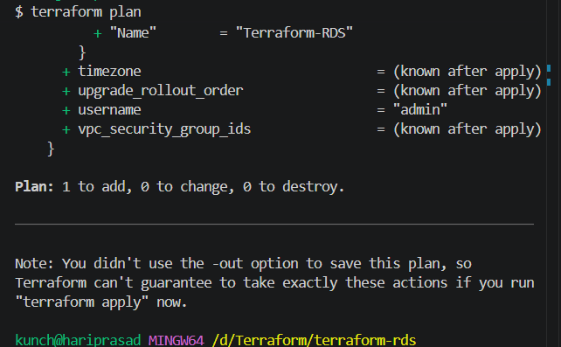
Step 4 — Create RDS
terraform apply
Enter:
yes
Terraform will create:
RDS Instance
│
├── Engine: MySQL
├── Version: 8.0
├── Instance: db.t3.micro
├── Storage: 20 GB
└── Database: myappdb
Step 5 — Check the RDS instance
AWS Console:
AWS → RDS → Databases
You should see:
terraform-rds-demo
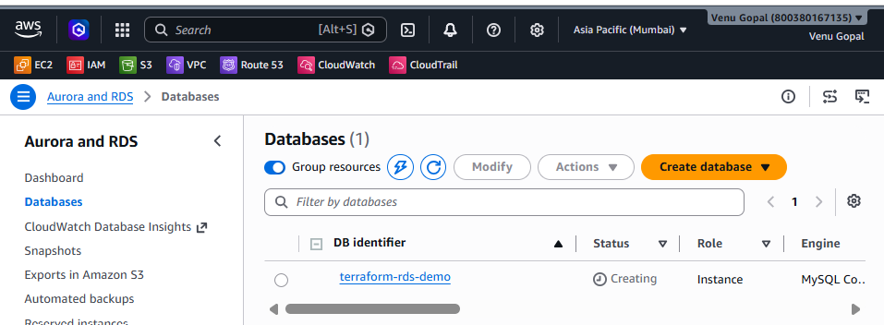
Step 6 — Destroy after practice
⚠️ RDS can incur charges, so destroy it when you're finished with the lab:
terraform destroy
Enter:
yes
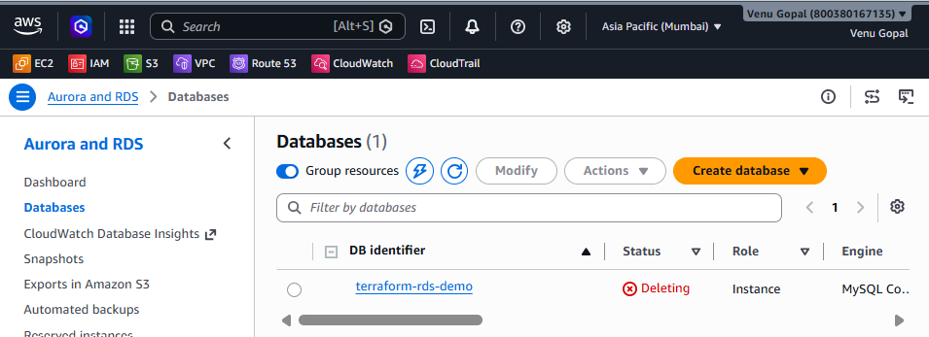

7.What is the use of terraform import?
Simple meaning
terraform import is used to bring an existing infrastructure resource under Terraform management.
Suppose you manually created an EC2 instance from the AWS Console:
AWS Console
↓
EC2 Instance
↓
Already exists
Later, you want Terraform to manage it.
You can import it:
terraform import aws_instance.web i-0123456789abcdef0
Terraform then records the relationship between:
Terraform Resource
↓
Existing AWS Resource
Important point
terraform import does not normally create the resource.
It imports the existing resource into the Terraform state.
You still need to write the corresponding Terraform configuration.
Example:
resource "aws_instance" "web" {
# configuration
}
Then:
terraform import aws_instance.web i-0123456789abcdef0
Real-world use
You have existing infrastructure created manually or by another tool and want to gradually bring it under Terraform management.
Interview answer
"terraform import is used to bring an existing infrastructure resource into Terraform's state so Terraform can manage it. It does not create a new resource; it establishes the relationship between an existing resource and a Terraform resource."

8.What is the use of terraform refresh?
Simple meaning
Refresh means:
Update Terraform's knowledge of the real infrastructure.
Imagine Terraform state says:
EC2 instance
Instance type = t3.micro
But someone changes the EC2 instance manually in AWS:
AWS
Instance type = t3.small
Terraform needs to know about the current infrastructure.
Historically:
terraform refresh
was used to update the state.
Important modern Terraform point
In modern Terraform versions, terraform refresh is deprecated. Instead, use:
terraform plan -refresh-only
or:
terraform apply -refresh-only
Example:
terraform plan -refresh-only
This lets Terraform compare/update its state based on the actual infrastructure without planning normal configuration changes.
Interview answer
"terraform refresh was used to synchronize Terraform state with the actual infrastructure. In modern Terraform, the recommended approach is terraform plan -refresh-only or terraform apply -refresh-only."

9.What is the use of Terraform workspaces?
Simple meaning
Terraform workspaces allow you to maintain multiple state files for the same Terraform configuration.
For example:
Development
↓
terraform configuration
↓
Dev state

Testing
↓
terraform configuration
↓
Test state

Production
↓
terraform configuration
↓
Prod state
Create a workspace:
terraform workspace new dev
Create another:
terraform workspace new test
Another:
terraform workspace new prod
Check the current workspace:
terraform workspace show
List workspaces:
terraform workspace list
Switch:
terraform workspace select prod
Example
resource "aws_instance" "web" {

instance_type = terraform.workspace == "prod"
? "t3.small"
: "t3.micro"

}
So:
dev → t3.micro
test → t3.micro
prod → t3.small
Important real-world point
Workspaces are useful, but they are not always the best way to separate dev/test/prod in larger production environments. Many teams use separate directories/configurations and separate state backends for stronger isolation.
Interview answer
"Terraform workspaces allow the same Terraform configuration to use separate state files. They are useful when managing multiple environments with similar infrastructure, such as dev, test, and prod."
10.What is the use of Terraform backend?
Simple meaning
A backend determines where Terraform stores its state file and how state operations are handled.
By default, Terraform uses:
local backend
↓
terraform.tfstate
↓
Local machine
For a team, storing state locally is not ideal.
We can use a remote backend, such as Amazon S3.
Conceptually:
Developer 1 ──┐
│
Developer 2 ──┼──> Remote Terraform State
│
Jenkins ──────┘
Example:
terraform {
backend "s3" {
bucket = "my-terraform-state"
key = "project/terraform.tfstate"
region = "us-east-1"
}
}
Benefits
A remote backend provides:
- Centralized state
- Team collaboration
- State persistence
- Access control
- State locking support depending on backend/configuration
- Better CI/CD integration
Interview answer
"A Terraform backend defines where Terraform stores its state and how state is accessed. In a team environment, I prefer a remote backend such as S3 with appropriate locking because it allows multiple engineers and CI/CD systems to work with shared infrastructure safely."
11.What is the use of Terraform output block?
Simple meaning
The output block displays useful information after Terraform creates resources.
For example, after creating EC2:
output "instance_public_ip" {
value = aws_instance.web.public_ip
}
After:
terraform apply
Terraform can display:
instance_public_ip = "54.x.x.x"
Another example
output "instance_id" {
value = aws_instance.web.id
}
You can retrieve it later:
terraform output
Or:
terraform output instance_public_ip
Real-world use
Outputs are useful for passing information to:
- Users
- CI/CD pipelines
- Other Terraform configurations
- Automation scripts
- Infrastructure consumers
Interview answer
"Terraform output blocks expose useful information from the Terraform configuration, such as an EC2 instance ID, public IP, load balancer DNS name, or RDS endpoint."
12.What is the use of Terraform data sources?
Simple meaning
A data source reads existing information without creating a new resource.
Think:
resource
↓
CREATE / MANAGE

data source
↓
READ / LOOK UP
For example, instead of hard-coding an AMI ID:
data "aws_ami" "amazon_linux" {
most_recent = true

owners = ["amazon"]

filter {
name = "name"
values = ["al2023-ami-*-x86_64"]
}
}
Then:
resource "aws_instance" "web" {
ami = data.aws_ami.amazon_linux.id
instance_type = "t3.micro"
}
Terraform looks up an existing AMI and uses its ID.
Other examples
Data sources can retrieve:
Existing VPC
Existing subnet
Existing AMI
Existing AWS account information
Existing Route 53 zone
Existing security group
Interview answer
"Data sources allow Terraform to read information about existing infrastructure or external data without creating or managing that resource. They are useful for dynamically retrieving values such as AMI IDs, VPC IDs, subnet IDs, and availability zones."
13.What is the use of Terraform provisioners?
Simple meaning
Provisioners allow Terraform to perform actions after a resource is created or before it is destroyed.
Common provisioners include:
local-exec
remote-exec
file
local-exec
Runs a command on the machine where Terraform is running.
Example:
resource "aws_instance" "web" {

ami = "ami-xxxxxxxx"
instance_type = "t3.micro"

provisioner "local-exec" {
command = "echo EC2 instance created"
}
}
remote-exec
Runs commands on the remote machine.
Example:
provisioner "remote-exec" {
inline = [
"sudo yum update -y",
"sudo yum install nginx -y"
]
}
Important ⚠️
Provisioners are generally considered a last resort.
Prefer:
User data
Cloud-init
AWS Systems Manager
Configuration management
Immutable images
when appropriate.
Interview answer
"Terraform provisioners execute scripts or commands during resource creation or destruction. They include local-exec, remote-exec, and file provisioners. However, provisioners should generally be a last resort because they can make infrastructure less predictable and harder to manage."
14.What is Terraform statefile locking and why is it important?
Simple meaning
State locking prevents two Terraform operations from modifying the same state at the same time.
Imagine:
Terraform State
│
┌─────────┴─────────┐
│ │
Jenkins Developer
│ │
terraform terraform
apply apply
If both try to modify state simultaneously, you could have a race condition.
Locking prevents that.
Developer
│
▼
Acquire lock 🔒
│
terraform apply
│
Update state
│
Release lock 🔓
Another Terraform process has to wait or fail rather than modifying the same state concurrently.
Why is it important?
It helps prevent:
- State corruption
- Concurrent modifications
- Conflicting Terraform operations
- Infrastructure inconsistencies
Example
Suppose Jenkins is running:
terraform apply
and another engineer runs:
terraform apply
at the same time.
State locking helps ensure only one operation modifies that state at a time.
Interview answer
"Terraform state locking prevents multiple Terraform processes from modifying the same state simultaneously. It is important because it prevents race conditions and helps protect the consistency of the Terraform state."
15.What is the use of Terraform dynamic block?
Simple meaning
A dynamic block lets you generate repeated nested configuration blocks dynamically.
Suppose a resource needs multiple ingress rules.
Without dynamic blocks:
ingress {
from_port = 80
to_port = 80
}

ingress {
from_port = 443
to_port = 443
}
With a dynamic block:
variable "ports" {
default = [80, 443]
}

resource "aws_security_group" "web" {

name = "web-sg"

dynamic "ingress" {
for_each = var.ports

content {
from_port = ingress.value
to_port = ingress.value
protocol = "tcp"
cidr_blocks = ["0.0.0.0/0"]
}
}
}
Terraform generates:
Ingress 80
Ingress 443
Why use it?
It avoids repetitive code.
Input list/map
↓
dynamic block
↓
Multiple nested blocks
Interview answer
"A dynamic block is used to dynamically generate repeated nested blocks within a Terraform resource. It is useful when the number of nested blocks depends on variables or collections, such as multiple security-group ingress rules."
16.What is Terraform null_resource and when do we use it?
Simple meaning
null_resource is a Terraform resource that doesn't represent an actual infrastructure object.
It can be used to run actions based on Terraform lifecycle changes.
Example:
resource "null_resource" "example" {

provisioner "local-exec" {
command = "echo Hello Terraform"
}
}
It doesn't create:
EC2
S3
RDS
VPC
Instead, it gives Terraform a resource lifecycle to attach an action to.
Example use case
You want to run a script after an EC2 instance is created:
resource "aws_instance" "web" {
ami = "ami-xxxxxxxx"
instance_type = "t3.micro"
}

resource "null_resource" "configure" {

depends_on = [
aws_instance.web
]

provisioner "local-exec" {
command = "echo Configure server"
}
}
Terraform creates:
EC2
↓
null_resource
↓
Run command
Important modern Terraform point
For many use cases, null_resource has been superseded by the Terraform built-in terraform_data resource, especially when you need a resource solely to participate in Terraform's dependency/lifecycle model.
Example:
resource "terraform_data" "example" {
input = "Hello Terraform"
}
So in a modern Terraform project, consider whether terraform_data, user data, cloud-init, or another native mechanism is more appropriate.
Interview answer
"null_resource is a resource that doesn't create actual infrastructure. Historically, it was used to trigger provisioners or actions based on dependencies and changes. In newer Terraform configurations, terraform_data is often preferred for this type of lifecycle/data behavior."

